NTARF# <<NTARF #>> s. 2026
[NON-TRAVEL] ACTIVITY REQUEST FORM

Name of Requester | <<Name of Requester>> (<<College/Office/Project>>)
Date Filed | <<Timestamp>>
Activity Requested | <<Activity Requested>>
Main Organizer | <<Main Organizer>>
Justification/Explanation | <<Justification/Explanation>>
Venue | <<Venue>>
Date & Time of Activity | <<Date of Activity>> TO <<Date of Activity End>>  (<<Time of Activity Start>> TO <<Time of Activity End>>)
Involved WPU Personnel | <<Involved WPU Personnel (Position)>>
Type of Involvement | <<Type of Involvement>>
Requested Support | <<Requested Support (Check all that apply)>>
Funding Charged to | <<Funding Charged to>>, <<Funding Specifier>>
Total Estimated Amount | <<Total Estimated Amount>>
Status and Notes | <<Final Approval>>  <<Notes from Approver or Endorser>>  <<Notes re Fund Availability>>  <<Venue or PMES Notes>>

Recommending Approval:
(Endorsed through NTARF System)  <<Applicable Endorser's Name>> | (Endorsed through NTARF System)  <<Fund Availability Certified By>> | (Endorsed through NTARF System)  <<Endorser for Venue Availability>> | (Endorsed through NTARF System)  <<Endorser for Electricity and Generator Use>>
Immediate Supervisor | Budget/Accounting | Facility In-Charge | PMES Supervisor

Approved:
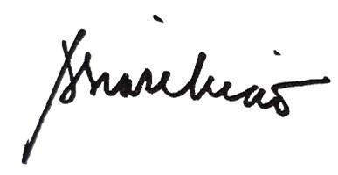

Amabel S. Liao, PhD
University President

